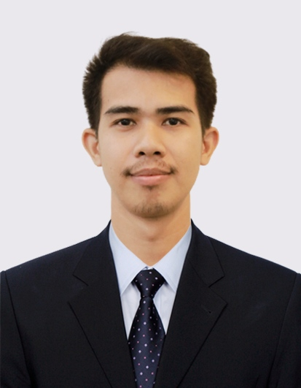**YE LINN HTET**

**FULL STACK DEVELOPER**

**Yangon, Myanmar**

**(+959) 252482969**

**yelinnhtet9598@gmail.com**

**linkedin.com/in/yelinnhtet**

**https://yelinnhtet.github.io/**

**ABOUT ME**

Innovative and hardworking developer with six years of extensive hands-on experience in designing and developing web applications from initial to final deliverable. Love learning new technologies and a quick learner. An experienced team player with excellentcommunication, interpersonal skills, and ability to work independently under pressure.

**EXPERIENCE**

**Senior Software Engineer** Nov 2023 – Now

**Markono Group Pte Ltd, Singapore (Myanmar based)**

* Took responsibilities for data integration from the customer feed to the system
* Developed enterprise solution architecture for the data migration
* Solving the problems and troubleshoot the data issues
* Collaborated with team members and guide to juniors
* Weekly project meeting with Boss, Project Manager and team members, and discuss the features and requirements

**Senior PHP Developer** Jun 2023 – Nov 2023

**Secret Code Co., Ltd, Yangon**

* Took responsibilities for both frontend and backend development
* Developed enterprise web and mobile application
* Liaised with team members and guide to juniors
* Weekly project meeting with Boss, and discuss the features and requirements

**Senior Developer** Sep 2018 – Feb 2023

**Innovative Global Wave Technology Co., Ltd, Yangon**

* Participated as an active developer and took responsibilities for both frontend and backend development
* Developed e-government enterprise projects and supported customer training as required
* Collaborated with team members, project manager, quality assurance testers, and CTO as needed
* Weekly project meeting with Business Development Officer, Project Manager and Director, and discuss the features and requirements

|  |  |
| --- | --- |
| **PROGRAMMING AND DATABASE**   * PHP, C#, Java * Asp.Net MVC * .Net Core API * Entity Framework * HTML, CSS, JavaScript * Angular, Bootstrap, Vue * MySQL, MS SQL | **EXPERT TOOLS AND IDES**   * Visual Studio Code * Visual Studio * Sublime Text, HBuilder X * Postman, Talend Open Studio * phpMyAdmin, Jenkins * SQL server Management Studio * Git, Agile, Scrum, Trello |

**PROJECTS**

1. Booksmart (E - commerce)
2. RCEP Mall Web and Mobile app (Using Vue, Angular and Laravel)
3. Municipal Mobile App (Using C# .Net core API for backend)
4. Online Business License Registration and Administration System (Using Angular for frontend and PHP for backend)
5. Household Management System (Using Angular for frontend and PHP for backend)
6. Housing Management System (Using Angular for frontend and PHP for backend)
7. Property Taxation System (Using Angular for frontend and PHP for backend)

**EDUCATION**

University of Computer Studies, Magway - MYANMAR

Bachelor of Computer Science **(B.C.Sc)** Dec 2012 – Nov 2017

**LANGUAGE**

* English: Good command in both written and spoken
* Myanmar: Ability to read, write and speak fluently as it's my mother tongue

**CAREER INTERESTS**

* Position Finding: Permanent
* Notice Period: One month